1. circularqueue(using array).cpp (output)

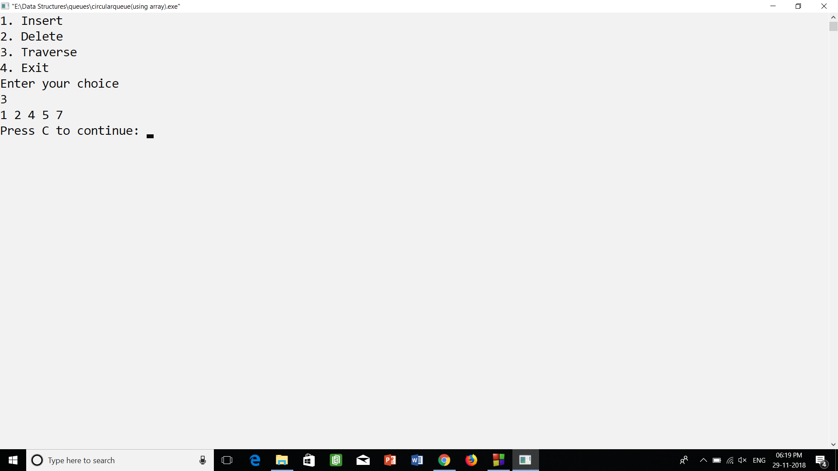

1. linearqueue(using array).cpp (output)

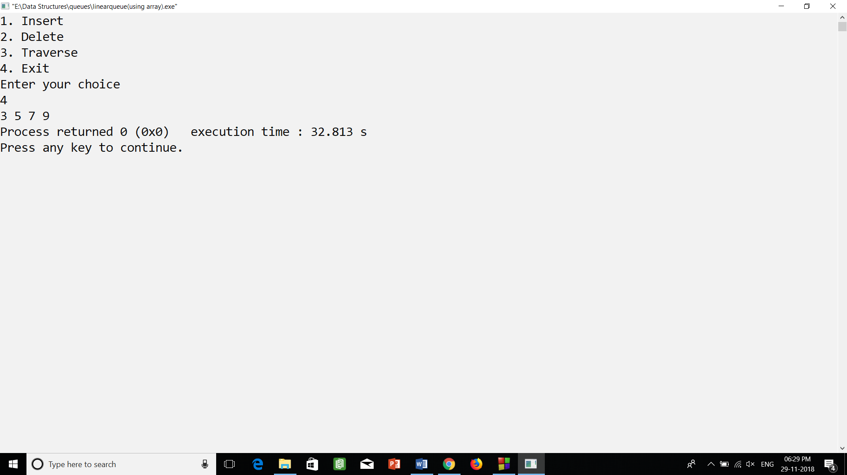

1. priority queue(using linked list).cpp (output)

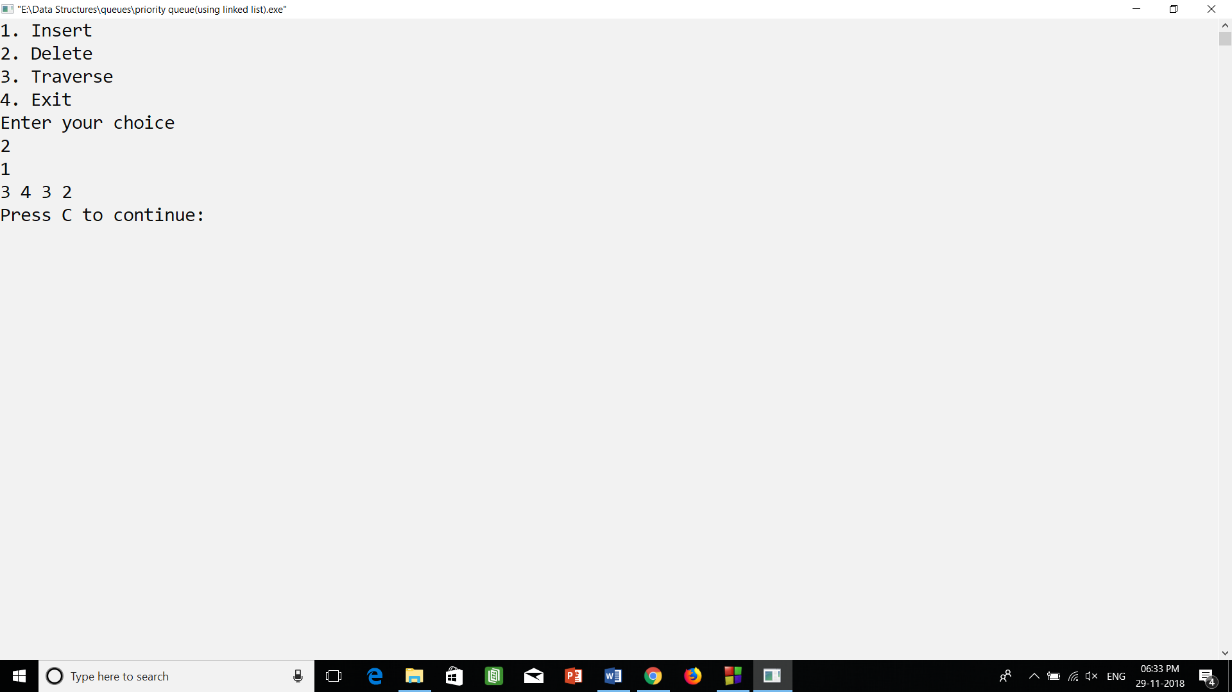

1. queue using linked list.cpp (output)

